**ANS 1:**

1. grep -n **“#**include**”** hello.c

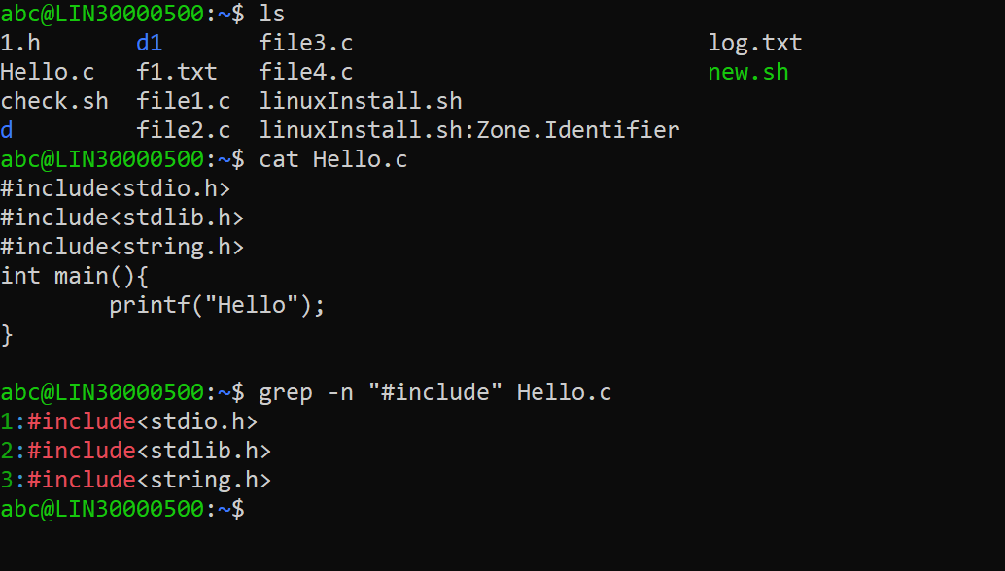

1. grep -v “#include” hello.c

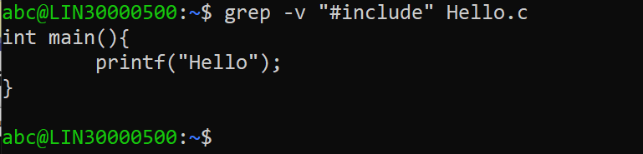

1. grep -n “main” hello.c

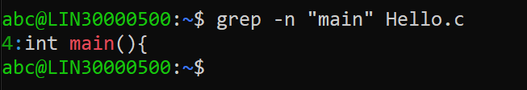

1. grep “[{*} (*)]” *.c

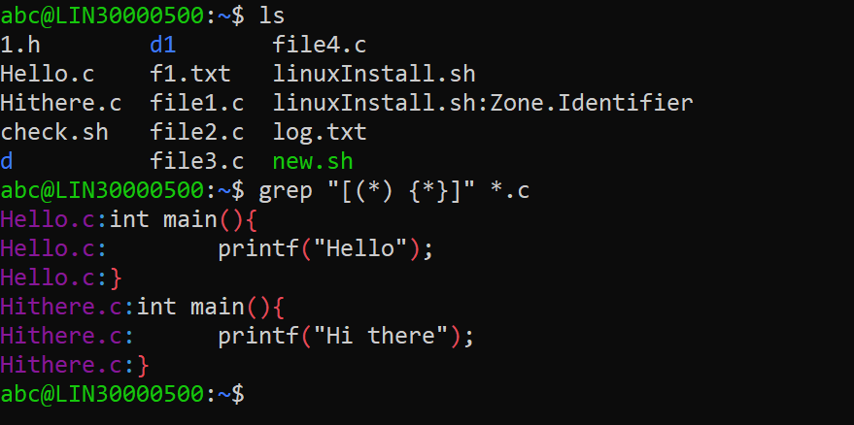

**ANS 2:**

